Swearing-in of new AUABC Board Members and election of Bureau
Apr 25, 2023

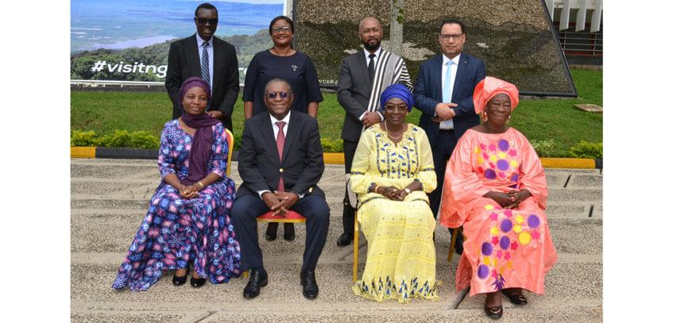
SHARE
Arusha, Tanzania: The African Union Advisory Board against Corruption (AUABC) held a ceremony to swear-in newly appointed Board Members on 25th April 2023 at the commencement of the 43rd Ordinary Session of the Board held in Arusha, Tanzania.
The newly appointed Members who were sworn-in for their first term of office are:
- Kwami Edem Senanu, Ghana
- Yvonne Mutepuka Chibiya, Zambia
- Tsiry Harivelo Lalaina Eric Razafimandimby, Madagascar
Also appointed and sworn-in for their second and final term of office are:
- Pascoal Antonio Joaquim, Angola
- Seynabou Ndiaye Diakhate, Senegal
The Board has elected the following Members to serve in its Bureau:
- Seynabou Ndiaye Diakhate, Chairperson
- Pascoal Antonio Joaquim, Vice Chairperson
- Marthe Dorkagoum Boularangar, Rapporteur
About the AUABC: The African Union Advisory Board against Corruption (AUABC) was established by Article 22 of the African Union Convention on Preventing and Combating Corruption which entered into force on 5th August 2006. The Board is comprised of eleven (11) Board Members and has the broad mandate to promote and encourage the adoption of measures and actions by State Parties to prevent, detect, punish and eradicate corruption and related offences in Africa. Its headquarters is in Arusha, Tanzania.
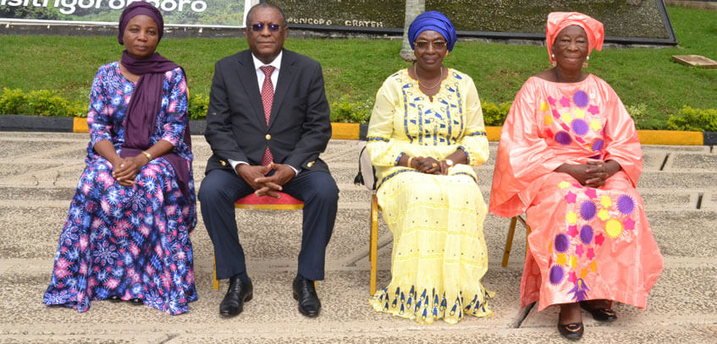
The incoming Bureau with the Executive Secretary (Left)

